Different sensors to measure aerosol

Instrument used by NENO-AM was developed by UTIAS/SFL.

Rejected ones

1. OLS
2. MODIS
3. VIIRS
4. SCIAMACHY
5. POLDER
6. AVHRR

Reason for rejection was mainly high mass, volume, power requirement.

Sensors about which we can think:

1. APS
2. MISR
3. MERIS
4. SAGE
5. Wide Field camera (used on Calipso)
6. ERBE ( used on ERBS ) – ERBE team themselves developed it

How measured data should be reported?

|  |  |  |  |
| --- | --- | --- | --- |
| **Data Product** | **Measurement Capabilities and Uncertainties** | **Data Product Resolution** | |
| **Horizontal** | **Vertical** |
| **Aerosols** | | | |
| Height, Thickness | For layers with β > 2.5 x 10-4 km-1 sr-1 | 5 km | 60 m |
| Optical depth, τ | 40% * | 5 km | N/A |
| Backscatter, βa(z) | 20 - 30% | 40 km 40 km | Z < 20 km 120 m Z ≥ 20 km: 360 m |
| Extinction, σa | 40% * | 40 km 40 km | Z < 20 km 120 m Z ≥ 20 km: 360 m |
|  |  |  |  |

Some other related useful inf.

IIT Kanpur students have used infrared imager (indigenously developed).

**Sensors with reason of rejection**

1)POLDER-P

|  |  |
| --- | --- |
| Instrument mass, volume | 32 kg, 0.8 m x 0.5 m x 0.25 m |
| Power consumption | 50 W (image mode) |

2) MODIS

|  |  |
| --- | --- |
| Telescope | 17.78 cm diam. off-axis, [afocal](https://en.wikipedia.org/wiki/Afocal_system) (collimated), with intermediate field stop |
| Size | 1.0 × 1.6 × 1.0 m |
| Weight | 228.7 kg |
| Power | 162.5 W (single orbit average) |

3) SCIAMACHY

|  |  |
| --- | --- |
| Optical Assembly | 109 cm 65 cm 101 cm |
| Electronic Assembly | 82 cm 90 cm 28 cm |
| Radiant Cooler Assembly | 51 cm 91 cm 62 cm |
| Total Mass | 215 kg |
| Power Consumption | 140 W |
|  |  |

4)OLS – Even though I have to reject it but then also I would like to go in some detail in it because it can measure in night also using moonlight (till quarter moon).It was built by Northrop Grumman, Westinghouse Corporation. It was used on DMSP.

The OLS instrument consists of two telescopes and a photomultiplier tube (PMT). The detectors sweep back and forth in a "whiskbroom" fashion. The scanning telescope of OLS is a f/5.8 Cassegrain design with a 20.3 cm clear aperture and an effective collecting area of about 185 cm2. The telescope has an effective focal length of 122 cm. Two telescope calibration mirrors intercept the normal FOV at the edge of scan with hot and cold loads of known temperatures. The light from the telescope is split into two channels by a beam splitter, and sent via relay optics to the visible and infrared focal planes, as well as to the photo multiplier tube that provides useful nighttime visible imagery. The telescope images over a scan angle of ±56.25º which corresponds to a swath width on the ground of 2960 km

Swath width = 3000 km from a nominal 833 km orbit altitude. OLS provides global coverage in both visible (L data) and IR (T data) modes. Fine resolution data with a nominal linear resolution of 0.56 km are collected as needed day and night by the IR detector, and as needed during daytime, by a segmented silicon diode detector (LF data). **A high resolution photometer tube is used for nighttime visible imagery.**

On-board data smoothing (averaging) can be done to reduce the data rate by a factor of 25, smoothing electronically the pixels in the cross-track direction and digitally averaging in the along-track direction. However, smoothing is only done in cases to cope with current recorder limitations. When this mode is used, the original high-resolution imagery cannot be recovered.

OLS utilizes three types of detectors:

• A silicon photoconductive diode is used for daytime VIS imagery. Three segments in the detector provide for a nearly constant resolution across the swath. Two smaller segments are used for scan angles > 41º, all three segments are summed in the middle portion of the scan about nadir.

• A two-segment HgCdTe photoconductive detector is used for the TIR channel. The detector is cooled to 108 K by a cone cooler. The two detector segments are used on the far right and left parts of the scan and are summed over the middle portion of the scan (within ±41º).

• **A single PMT detector is used for nighttime visible data [a GaAs opaque photocathode and multiple dynode PMT)**.

**Sensor about which we can think**

1)AVHRR

The AVHRR/3 instrument weighs approximately 72 pounds, measures 11.5 inches X 14.4 inches X 31.4 inches, and consumes 28.5 watts power.

The instrument utilizes a 20.32 cm (8 inch) diameter collecting telescope of the reflective Cassegrain type.

**5 cameras** (one each for 600nm, 900 nm, 3500nm & 2 for 11000nm). AVHRR measures the intensity of sunlight as it reflects off aerosols using the dark ocean as background.

Can be operated from orbit of 833km

For complete inf. Of AVHRR see 

The third generatioin of the AVHRR was built by ITT Aerospace - Optical Division in Fort Wayne, Indiana, USA.

|  |  |  |  |
| --- | --- | --- | --- |
| 2)SAGE |  |  |  |

The SAGE II instrument vertically scans the limb of the atmosphere during spacecraft sunsets and sunrises (fifteen sunsets and fifteen sunrises each day). The 57 degrees inclined orbit of the ERBS spacecraft evenly distributes the SAGE II measurements every 24 degrees of longitude along a slowly shifting latitude circle.

SAGE 2 was used by **Earth Radiation Budget Satellite** ( altitude of 575 km, geocentric, low earth orbit, period of 96.4 min)

SAGE 3 was used by **Meteor-3M No.1**. (altitude of 1000km , geocentric, sun-synchronous orbit period of 105.3 minutes)

Manufactured by NASA

It was used on CALIPSO ([Geocentric](https://en.wikipedia.org/wiki/Geocentric_orbit), [Sun-synchronous](https://en.wikipedia.org/wiki/Sun-synchronous_orbit), 702 km altitude, 98.2176 deg inclined & period of 98.5 min)

|  |  |
| --- | --- |
|  | |
|  |  | |
|  |  | |
|  |  | |
|  |  | |
|  |  | |
|  |  | |
|  |  | |
|  |  | |

3) **MISR – nice idea for constellation**

9 cameras – they all together cover 4 wavelengths red, blue ,green, near-infrared wavelengths

One camera points toward the [nadir](https://en.wikipedia.org/wiki/Nadir), while the others provide forward and aftward view angles at 26.1°, 45.6°, 60.0°, and 70.5°

It was used on TERRA (altitude of 710 km with semi-major axis of 7080 km) (geocentric sun-synchronous orbit low earth orbit with period of 98.8 minutes)

It was manufactured by NASA

|  |  |
| --- | --- |
| Spectral Bands (Solar Spectrum Weighted) | 446.4, 557.5, 671.7, 866.4 nanometers |
| Spectral Bandwidths | 41.9, 28.6, 21.9, 39.7 nanometers |

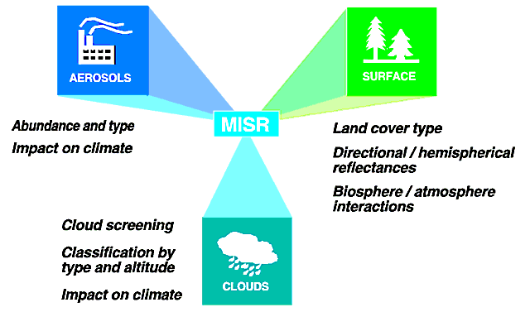

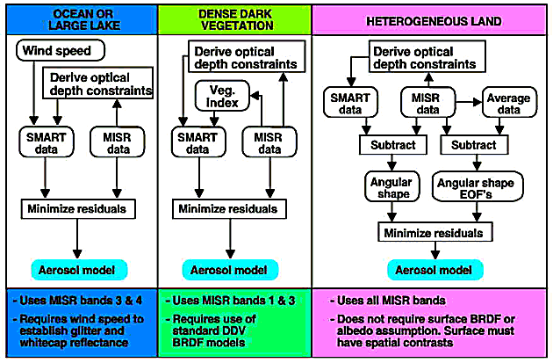

4)MERIS

Measures the reflectance of the Earth (surface and atmosphere) in the solar spectral range (390 to 1040 [nm](https://en.wikipedia.org/wiki/Nanometre)) and transmits 15 spectral bands back to the [ground segment](https://en.wikipedia.org/wiki/Ground_segment). MERIS was built at the [Cannes Mandelieu Space Center](https://en.wikipedia.org/wiki/Cannes_Mandelieu_Space_Center). Used by Envisat

5) APS (Aerosol Polarimeter Sensor) – Multispectral polarimetric sensor (spectrophotopolarimeter) – collects radiation in visible, near-infrared & short wave infrared (VNIR, SWIR) band & retrieves aerosol parameter using multispectral photopolarimetry.

Parameters retrieved

1. Aerosol optical thickness
2. Aerosol particle size
3. Aerosol refractive index
4. Aerosol single-scattering albedo
5. Aerosol shape (sphericity)
6. Cloud particle size distribution